Gas Smart Change of Supply Read Project

Interim Report

Author: | Andy Baugh
Version: | V1 FINAL
Date: | 9th July 2014

Contents

Background 3
Project Structure 4
Meetings 4
Project Members 4
Project Report Timescales 5
Links to other workstreams 5
Definitions Table 5
Comparisons Between Current and Future Processes 6
High Level Current Process 6
Issues with Current Process 6
High Level Future Process – Option 1 7
High Level Future Process – Option 2 7
Benefits provided by smart meters 8
Additional benefits/risks of Option 1 8
Additional benefits/risks of Option 2 8
Outputs from the Project 9
Scope 9
Change of Supply Read 9
Access and transfer of security credentials 9
Impact on Settlements 10
Communication Failures 10
Under / Over Billing Issue 11
Smart / Legacy Process Indicator 13
Smart Meter Configuration 13
Validation 14
Read Submission SLAs 14
Rules for Suppliers opting in and out of the DCC 15
Security of Communications to the Meter 15
Items to be addressed through other Workstreams 16
Implementation Date and Style 16
Billing Principles and Customer Communication 16
Utilisation of the NOSI flow 16
Disputed Reads Process Amendment 17
Governance Framework and I&C Suppliers 17
Updating of Relevant Industry Codes 17
Comparisons Between Electricity and Gas 18
Appendix A - Current Process Map 20
Appendix B - Future Process Map Option 1 21
Appendix C - Future Process Map Option 2 22

Background

Smart meters will be rolled out nationwide by the end of this decade. This is an ideal opportunity to improve a number of processes as the industry will have better quality data available much more quickly. As a result Ofgem established the Smarter Markets programme focussing on four main areas of opportunity following smart meter roll out:

- Electricity Demand Side Response
- Electricity Settlements Reform
- Customer Empowerment and Protection
- Change of Supply Reform

The Change of Supply Reform project primarily looks at long term changes, however, where quick win opportunities exist that will improve customer experience, Ofgem are keen to see these improvements implemented as soon as possible. One such opportunity is the possibility of suppliers obtaining the change of supply reading from the smart meter at Supply Start Date and using that read more quickly instead of waiting for the current process which can take 2 – 3 weeks for the Change of Supply reading to be processed and sent to both suppliers.

As a result two separate industry workstreams were initiated, one each for gas and electricity:
- Electricity: managed via Elexon through workgroup Issue 53 and change proposal P302
- Gas; managed via a joint UNC/SPAA workgroup - this document summarises the outputs from the gas workstream

As Issue 53 had already completed and delivered an approved report by the time this gas project was initiated, for consistency the gas workstream agreed to align with electricity wherever appropriate. Therefore, many of the outputs and agreements from the gas workstream have been carried over from the electricity workstream.

The purpose of this report is to document the outputs from the gas workstream. The report will then be issued to SPAA, UNC and IGT UNC Panels for views and comments with a recommendation to initiate a SPAA workgroup to further consider which option is preferable, particularly taking into account the need to achieve timely and accurate customer billing. It is envisioned that the SPAA group/Gas CoS meter read group will then issue a final report to panels and Ofgem, with a view for getting approval for a modification to be launched.

Project Structure

Meetings

Four meetings have been held with Electralink as the Secretariat and npower as the Chair. All minutes and content of the meetings can be obtained via Electralink.

Project Members

Members from the industry were invited to form a workstream to look at the opportunities for gas. The members were from the following organisations:
- Electralink
- Ofgem
- DECC
- DCC (as a consulted party)
- Siemens
- Xoserve
- National Grid
- Elexon
- SGN
- GTC
- Npower
- British Gas
- EDF Energy
- E-ON
- Scottish Power
- Scottish and Southern Energy

This document has been compiled with comments and inputs from the following people:

Person | Organisation
Adam Iles | British Gas
Trevor Clarke | E-ON
Bryan Hale | EDF Energy
Paul Saker | EDF Energy
Andy Baugh | npower
Rachel Hay | Ofgem
Claire Hemmens | Scottish and Southern Energy
Paul Orsler | Xoserve
Steve Nunnington | Xoserve

Project Report Timescales

The following table identifies the timescales to approve the report.

Action | Deadline | Owner
Issue draft report to group | 16th June | Andy Baugh
Review and provide comments to AB | 25th June | ALL
Update report and re-issue to group | 30th June | Andy Baugh
Approve report | 2nd July | ALL
Conference Call in case of outstanding issues | 3rd July | Electralink
Issue report to all panels | 9th July | Andy Baugh
IGT UNC Panel agreement | 16th July | IGT UNC Panel
UNC Panel agreement | 17th July | UNC Panel
SPAA Executive Committee agreement | 23rd July | SPEC
Conclude under and over billing workgroup | To be confirmed
Final report | To be confirmed
IGT UNC Panel decision | To be confirmed
UNC Panel decision | To be confirmed
SPAA Executive Committee decision | To be confirmed

Links to other workstreams

This project has links to the following workstreams

Workstream | Summary
CoS Reform | Ofgem led looking to reform the entire Change of Supply journey
Issue 53 | Elexon led investigating possibilities to obtaining SSD read from smart meter at CoS for electricity – equivalent to this project
P302 | Elexon led progressing outputs from Issue 53 into implementation
UNC461 | Amend gas day start time from 06:00 to 05:00

Definitions Table

Term | Definition
SSD | Supply Start Date – the date responsibility transfers from the old supplier to the new supplier
Losing/Old Supplier | The supplier the customer is registered with prior to SSD and responsibility is transferring from
Gaining/New Supplier | The supplier with whom the customer has agreed a new contract with and responsibility is transferring to on the SSD
DCC | Data and Communications Company – Industry party managing communication between the industry and customer smart meters
Xoserve | Industry agent to the Gas Transporters
GT and IGT | Gas Transporter and Independent Gas Transporter

Comparisons Between Current and Future Processes

High Level Current Process
- See Appendix A
- The customer agrees a contract with their preferred supplier and the change of supply process begins
- Around SSD the gaining supplier will attempt to obtain a read from the customer; this is most commonly by the customer providing it via a call/letter or the gaining supplier requesting an agent to visit the premise and take an actual reading
- The gaining supplier submits this reading to Xoserve up until SSD + 10 days
- Xoserve then validate the reading provided from the gaining supplier
- If that reading passes validation, Xoserve will issue the same reading to both losing and gaining supplier as the official Change of Supply read
- If the reading fails validation or a read hasn’t been submitted to Xoserve, Xoserve will estimate a reading and issue that deemed reading to both losing and gaining supplier as the official Change of Supply read
- The losing supplier will check the Xoserve read (actual or estimated) against previous readings and where they align the losing supplier will issue the final bill to the customer
- Where the Xoserve read does not fall in line with the losing supplier’s read history, the losing supplier will initiate the disputed reads process or accept it if it is within their tolerance levels
- The gaining supplier will check the Xoserve read against the read they submitted. If they align the gaining supplier will use the Xoserve read as the opening read to bill the customer
- If the Xoserve read does not align and is outside of the gaining supplier’s tolerance levels, the gaining supplier will initiate the disputed reads process

Issues with Current Process
- To obtain an actual read the process is reliant on the customer providing the reading or a site visit is completed
- The customer can be inconvenienced if they are contacted to provide a reading
- Agent visits can be costly and cannot guarantee an actual read as the customer may be at work, on holiday etc

The above should be delivered with smart metering without additional change, however, the following items will be addressed specifically by this project:

- The losing supplier is reliant on the gaining supplier and therefore at a disadvantage
- There is a delay to the losing supplier being able to issue the final bill to the customer
  - New supplier has up to SSD+10 to obtain read and Xoserve’s operating practices are to return a read that has been accepted and not rejected within 2WD. As a result, suppliers may only get a billing read as late as SSD+12
  - If the Gaining Supplier is unable to obtain a reading, or if the read is rejected, the process is reliant on Xoserve providing an estimated read which could be 15 days after SSD (on average 35% of annual CoS reads are estimated, this figure includes estimates generated as a result of rejected reads and missing reads)

High Level Future Process – Option 1
- See Appendix B
- The customer agrees a contract with their preferred supplier and the change of supply process begins
- Both suppliers will access a reading taken by the customer’s smart meter at midnight on SSD (they can access this up to 30 days after SSD). This helps to assure that both Suppliers are using the same reading data (and therefore not creating billing gaps).
- At this point it is envisioned that the losing supplier will issue a final bill to the customer using that reading (if it is in line with billing history) and the gaining supplier submits this reading to Xoserve. If the reading is not in line with previous billing history the losing supplier will investigate and not issue the final bill at this stage.
- Xoserve then validate the reading provided from the gaining supplier
- If that reading passes validation, Xoserve will issue the same reading to both losing and gaining supplier as the official Change of Supply read
- If the reading fails validation or a read hasn’t been submitted to Xoserve, Xoserve will estimate a reading and issue that deemed reading to both losing and gaining supplier as the official Change of Supply read (see page 10 for future Xoserve validation rules)
- It is envisaged that the losing supplier will check the Xoserve read against their SSD midnight read and where they align the process will end for the losing supplier
- The gaining supplier will check the Xoserve read against their SSD midnight read (and potentially also the losing supplier’s read on the NOSI flow). If they align the gaining supplier will use the Xoserve read as the opening read to bill the customer
- Where the Xoserve read does not match the SSD midnight read, the losing (or potentially the gaining) supplier will initiate appropriate processes to resolve the discrepancy as quickly as possible and prevent inappropriate billing (see note below)

High Level Future Process – Option 2
- See Appendix C
- The customer agrees a contract with their preferred supplier and the change of supply process begins
- Both suppliers will access a reading taken by the customer’s smart meter at midnight on SSD (they can access this up to 30 days after SSD). This helps to assure that both Suppliers are using the same reading data (and therefore not creating billing gaps).
- It is envisioned that both suppliers would have the ability to send the midnight read into Xoserve to be validated and disseminated as the official Change of Supply read.
- Xoserve will accept the read from whichever supplier submits it first and will validate it and send it to both suppliers.
- Each supplier would be expected to check that Xoserve’s read matches the SSD midnight read they have obtained for the meter. If so, they can be confident in progressing with billing.
- If not, and either supplier believes that they have a more accurate read than is provided by Xoserve, it can be disputed/an alternative billing read can be agreed between the suppliers.

NOTE: The SPAA expert group is requested to initiate a workgroup to consider which reform option would best meet the objectives described in more detail in the section below titled ‘under/over billing’. As part of this, it would be necessary to determine the appropriate process to follow under either option to ensure that any read discrepancies are quickly identified and resolved (through the disputes process or otherwise) to support timely and accurate billing.

Benefits provided by smart meters
- The customer is not inconvenienced with a request to provide a reading
- Costly agent visits are avoided
- Better customer experience
- As the read is taken directly from the meter at SSD the accuracy of CoS reads should improve both settlement and billing, improving trust and confidence in the industry

Additional benefits/risks of Option 1
- The losing supplier is not reliant on the gaining supplier nor Xoserve before issuing a final bill
- Enables very fast billing for the losing supplier, providing a better financial position for the customer who will receive a closing bill very quickly and not receive a closing bill until 1 month or so following this
  - old supplier should be able to bill from SSD onwards
- Closing bills are not delayed by any instances where the SSD midnight read fails validation despite being an accurate read (e.g. where asset mismatches have caused read to be rejected at validation)
- Consumer experience of change of supply process is more consistent across electricity and gas
- Checks across the closing and opening reads may take place after the closing bill has been issued, which could make resolution of issues more difficult in some instances

Additional benefits/risks of Option 2
- The losing supplier is not reliant on the gaining supplier to issue the final bill (nor is the gaining supplier reliant on the losing supplier as they are able to issue the read to Xoserve in the event the losing supplier does not)
- Enables fast billing for the losing supplier, providing a better financial position for the customer who will receive a closing bill quickly and not receive a closing bill until 1 month or so following this.
  - Old supplier could bill as early as SSD, but could be delayed by up to 2WD by Xoserve validation, or longer if it fails validation and estimate supplied is less accurate.
- Closing bill could suffer from undesirable delays where the SSD midnight read fails validation despite being an accurate read, and a cumbersome process must be initiated to re-establish the SSD midnight read as the appropriate billing read.
- Consumer experience of change of supply process is more consistent across electricity and gas

Outputs from the Project

Scope

The workstream felt a consistent process between gas and electricity should be delivered and therefore agreed to the scope defined through the electricity workstream Issue 53. Therefore this process will be mandatory to DCC serviced meters, as meters outside of the DCC are unlikely to be operated as smart by both Suppliers. However, the SPAA Expert group should consider whether the scope could be extended to SMETS1 DCC serviced meters as electricity change proposal P302 is looking to do the same.

Change of Supply Read

A consistent experience for the customer is a key objective of the reforms. On this basis, the workstream agreed to use the SSD midnight read as the CoS read, in line with Issue 53.

The workstream did investigate the possibility of using a 6:00 read in line with the gas start day:

- DECC advised an update of the tariff will automatically generate a write to the billing data log (i.e. a read). If the tariff is updated at 00:60 this could therefore generate a 06:00 read. If this was required as part of the new process, a change would be necessary to the access control rule to allow both parties to access it. DECC advised this could be possible, but noted use of this read may also be less reliable than a midnight read, given the midnight read is hard coded into the meter/DCC infrastructure and is not reliant on an ad-hoc command.

- The workstream decided that use of the 06:00 read would be less reliable as the tariff may not always need to be updated and equally it may not always be updated exactly at 06:00. It was identified that changing to a 06:00 read would also be different from electricity and could create customer confusion.

The group therefore felt it would create too much complexity and a decision was made to use the midnight read.

Issue 53 investigated the option of resetting the registers to zero on a change of supply event and were advised that the meter registers cannot be reset to zero. This was also confirmed with DECC through this Gas Smart CoS Read Project.

Access and transfer of security credentials

For electricity, the switch over from old supplier to new supplier happens at midnight. Meter access and transfer of security credentials would also happen at this time for electricity. The gas market, however, operates in a different manner. The start of the industry gas day is 06:00 and at this time GT central systems are updated to show the new gas supplier taking responsibility. At transfer of owner (TRF) stage Xoserve notifies DCC of the new supplier identification and then at 06:00 DCC will send the new credentials to the meter if an appropriate command has been issued by the Gaining Supplier. The workstream discussed two options:
- Access and transfer of security credentials to occur at midnight
- Access and transfer of security credentials to occur at 06:00

Allowing access and transfer of security credentials at midnight when the new supplier doesn’t take on supply until 06:00 was deemed to carry too much risk, especially in the scenario of a prepayment customer having meter/payment issues during the six hour gap.
The workstream agreed the more secure option from a customer perspective was for security access and transfer of credentials to occur at 06:00 in line with the official gas start day and updates to central systems.

NOTE: it should be noted that the gas day start could move from 06:00 to 05:00 to bring the UK into line with Europe. This change is being managed through UNC 461 with an estimated delivery date of October 2015.

Impact on Settlements

With the smart meter SSD change of supply read being obtained at midnight, but the actual change of supply taking place in line with legal responsibility at 06:00, the workstream felt it necessary to assess what impact on settlements this six hour gap may have.

Obtaining an accurate read from the meter at SSD would provide a better solution to the current process where a read may be obtained within 5 days either side of the SSD. The group therefore considered that the change would have a positive impact on settlement accuracy relative to current arrangements.

It was noted that analysis carried out during the Issue 53 assessment showed the likely frequency of a CoS event coinciding with a communications failure (estimated to be only 122 instances a year) would have an industry wide settlement impact of less than £50.

The SPAA Expert Group will be requested to assess the settlements impacts of the recommended reform approach in more detail, including consideration of whether there could be disproportionate impacts on different groups, e.g. small suppliers.

Communication Failures

The aim of the project is to implement a process where the read can be obtained directly from the meter at SSD. However, there needs to be contingency for instances where communication to the meter fails. The workstream approached DCC for clarification, who advised a communication service level of >99.9% would exist. It has also been confirmed that the SSD daily read log would be available for up to 31 days after SSD, so should a short term communication failure occur, either supplier could access the SSD daily read log at a later date. For longer term communication failures Xoserve would continue to provide a deemed reading up to SSD plus 15 days as per current arrangements, allowing the opening and closing processes to continue. During a period of communications failure the Gaining Supplier can attempt to obtain an actual reading by contacting the customer or arranging an agent visit.

To summarise an example:
- SSD is reached
- Neither supplier can obtain a read directly from the smart meter
- At SSD + 15 Xoserve deem a CoS read
- At SSD + 20 communications are restored and both suppliers obtain the SSD daily read log to determine the SSD midnight read
- Both suppliers compare the SSD midnight read and the Xoserve read to determine if the disputed reads process should be initiated
- During a communications failure period it is assumed both suppliers would perform regular checks to determine if communication has been restored

A further back up would be the losing supplier issuing the Notification of Old Supplier Information (NOSI) flow to the Gaining supplier advising them of the read history as per the current process (see page 12 for future utilisation of the NOSI flow)

Under / Over Billing Issue

The workstream identified a range of circumstances that could lead to under/overbilling under the new arrangements:

- Error made by new supplier in interrogating different internal registers/data being corrupted during upload from the meter, leading to old and new suppliers having a different value for the SSD midnight read (possible under options 1 and 2)
- New supplier being unable to access meter for read leading to Xoserve estimate being used by new supplier and SSD midnight read being used by old supplier (possible under options 1 and 2)
- Old supplier billing on SSD midnight read with subsequent validation failure (which could be caused by a range of underlying problems including meter malfunction, gas theft and asset data quality issues) leading to new supplier billing on Xoserve estimate (possible under option 1 only)

The worksream felt that the frequency of these events was likely to be low but ultimately difficult to predict. In line with customer expectations, Ofgem was keen for the risks to be designed out of process, or mitigated appropriately.

As noted above, the workstream considered it would be appropriate for SPAA to initiate a workgroup (prior to a modification being raised) to consider the options in this paper (and any additional options as appropriate) and establish how to most appropriately deliver the objectives of the reforms whilst mitigating the risks of under/over billing. The group discussed what principles this group should adhere to in assessing the options and felt that the objective and intended outcomes should remain as set out in the group’s terms of reference, namely:

Objective: to consider any relevant changes to the CoS meter read process for smart meters, to improve its efficiency in the context of smart meters and align outcomes for consumers when switching either fuel

Intended outcomes of any changes:
- Where possible, a party should not be reliant on competitors for the data it requires to meet its own and its customers’ needs
- The new supplier should be able to get the information it needs to complete the CoS without needing to appoint, and rely upon, agents to do so
- Where dependencies cannot be avoided, there should be effective measures in place to ensure the CoS process progresses as efficiently as possible and any potential detrimental impact on competition is minimised
- Alignment of outcomes for consumers such that they benefit from efficient and co-ordinated switching and billing across fuels.

In addition, a number of principles around billing were agreed:

Additional billing principles:
- Suppliers should be billing on the same, accurate read
- Rebilling should be minimised
- The process should enable the old supplier to bill quickly following CoS, such that closing and opening bills can be as staggered as possible

The table below sets out a view of how the options presented are understood to mitigate the risks described above. NB. An additional option (option 3) is also included in the table. This option was set aside on the basis that it does not address the dependency of the old supplier on the new supplier for the read.

 | Option 1 | Option 2 | Option 3
Old supplier bills on… | Unvalidated SSD midnight read, providing it is in line with read history | Validated read from Xoserve | Validated read from Xoserve
Read sent into Xoserve for validation by… | New supplier | Old supplier or new supplier (Xoserve take whichever CoS read they receive first as the CoS read) | New supplier  NB. The SLAs could be changed so that the new supplier is obliged to send the read into Xoserve e.g. within 1WD of SSD
New supplier bills on… | Validated SSD midnight read (a variant was also discussed where the new supplier was also required to bill on the unvalidated SSD midnight read)  NB. If the validated read differs from the unvalidated SSD midnight read, then prior to the new supplier billing, a process is initiated (e.g. disputes) to determine a common and accurate CoS read between suppliers. | Validated read from Xoserve (which will most frequently have originated from the old supplier since they will bill first) | Validated read from Xoserve
Mitigation of exceptions in circumstances 1, 2 and 3 (see previous page) | Old supplier will be able to identify if any of the three exceptions have occurred by checking the Xoserve read against their SSD midnight read, however choreography crucial if they are to flag a problem before new supplier bills.  New supplier only bills if the Xoserve validated read matches the original SSD midnight read, this addresses exception c). New supplier could also be required to wait on mandated NOSI flow from old supplier, this would address exceptions a) and b). | Exception c) mitigated.  Exceptions a) and b) mitigated by the fact that both suppliers will be billing on Xoserve’s read (or disputing it where they consider it wrong). | Exceptions mitigated.
Speed of closing bill | Very fast billing enabled.  Old supplier can bill from SSD onwards. | Fast billing enabled.  Old supplier can potentially bill from SSD onwards but will be reliant on Xoserve’s timeframes for validation (up to 2WD, see section on read submission SLAs for further discussion)  However increased numbers of bills could suffer from undesirable delays where the SSD midnight read fails validation, despite being correct (see validation section for discussion) | Fast billing enabled where new supplier complies with requirements.  Old supplier will be dependent on new supplier submitting (does not meet intended outcome of reform) and Xoserve’s timeframes for validation.

It should be noted that the workstream has not determined the appropriate process for resolving read discrepancies in options 1 and 2 and this would need to be considered by the SPAA workgroup.

Questions for a workgroup to consider therefore include (but not be limited to):
  - How the detail of the options could be designed to support timely and reliable identification of any issues with reads
  - How the detail of the options could be designed to support appropriate resolution of any issues, such that the billing principles can be met
  - Which of the reform options can most efficiently meet the objective, intended outcomes and additional billing principles

It is expected that the group will need to conduct further analysis of the costs/benefits of the options to make an informed decision.

Smart / Legacy Process Indicator

As this new process would only apply to smart meters serviced by the DCC, it is important for suppliers to be notified of the meter type as soon as possible. The losing supplier would have up to date knowledge of the meter so this would not be an issue for them. However, the gaining supplier would be notified via the following industry data flows:
- The meter type on the K14 flow which will be sent at confirmation acceptance (flow timing being implemented through quicker switching)
- The meter mechanism code on the TRF file at confirmation window commencement will identify whether the meter is SMETS 1 or SMETS 2
- The DCC service flag on the S98 record within the CFR and TRF files

Smart Meter Configuration

The workgroup discussed the options on whether the Gaining Supplier should reconfigure the meter on each CoS event or verify the meter.

The electricity group were considering the role that reconfiguration of the meter/verifying the configuration with meter, could play in avoiding the need for the MTDs to be passed from the old supplier’s agents to the new supplier and their agents.

P302 proposes that ‘The new Supplier will confirm the configuration of a smart Meter on Change of Supplier and notify the Standard Settlement Configuration (SSC) and Meter register configuration to the NHHDC and the Non Half Hourly Meter Operator Agent (NHHMOA).’

In gas, MTDs are held centrally so the same drivers for reconfiguring the meter do not exist. However it was suggested that due to data quality issues, the centrally held MTDs could sometimes be wrong and reconfiguring the meter on change of supplier could be beneficial in ensuring that the correct MTDs are always used.

The group noted that the TBDG design note on change of supplier explains ‘The operational licence condition (see condition 49.4 for electricity and 43.4 for gas) requires suppliers to provide access to Customer Information via the HAN, including the cost of energy consumed. This implies that the supplier must – subject to all reasonable steps – download the effective tariff to the meter from the time they become the registered supplier (i.e. from SSD). In order to satisfy this obligation, the gaining supplier will need to arrange for the CoS Update Security Credentials command, followed by other configuration commands discussed below, to be issued in advance of or at SSD.’ This should mean that the new supplier always either reconfigures or checks the configuration on the meter to make sure it matches the tariff.

The group therefore agreed to mimic the approach in electricity, noting that the arrangements outlined in TBDG should bring about reconfiguration/verification of the MTDs.

Validation

The group discussed the process of validation and identified that the SSD midnight read could be rejected at validation stage for a range of reasons, including:

- Meter malfunction
- Gas theft
- Xoserve not notified of meter exchange/asset mismatches in general
- No read history (caused by asset data quality issues)
- Property being vacant prior to change of supplier

Whilst the first two causes of rejection would require an estimate to be generated (or the meter to be fixed such that an accurate read could be obtained), the final 3 causes would mean that the SSD midnight read would remain the appropriate read to bill on. It was noted that the majority of reads tend to fail validation as a result of things like asset mismatches, rather than material problems at the meter. This led to some discussion around the potential benefits of billing on the unvalidated SSD midnight read (as option 1 proposes), and sorting out the causes of validation failures ‘behind the scenes’ such that the customer is not inconvenienced.

Xoserve advised the validation rules are being reviewed under project Nexus and considering the amount of development Xoserve are due to undergo it was deemed unnecessary to amend Xoserve read validation rules as part of this project. Initial understanding of the new Xoserve validation rules are as follows:
- Between 20% - 300% * - Xoserve will accept the reading
- Between 300% - 700% * - Xoserve will query the reading with the gaining supplier and only accept if the gaining supplier confirms the reading to be correct. No response will result in Xoserve estimating a deemed CoS read.
- Above 700% * - Xoserve will reject the read and estimate a deemed read

* relates to the tolerance level (i.e. xx% of AQ/365 x no. of days)

NOTE: the above criteria is still being reviewed and has not yet been approved

Read Submission SLAs

The option of shortening the SLA for the gaining supplier to submit the read to Xoserve was debated, however, it is in the gaining suppliers’ interest to submit the reading to Xoserve as soon as possible to obtain the CoS read to establish billing (and suppliers noted that they tend to do this as soon as they have the read) so reducing the SLA was deemed to be unnecessary.

From the date of receipt of the read from the Gaining Supplier, Xoserve’s operating practices are to return a read that has been accepted and not rejected within 2WD. With the vast majority of these being sent within 1 working day (on average Xoserve responds to all electronic files in around 20 minutes of receiving the file) it was deemed unnecessary to create formal SLAs in this area/alter working practices.

Rules for Suppliers opting in and out of the DCC

The new process will apply to meters serviced by the DCC so the workstream felt it necessary to understand the rules for suppliers opting in and out of DCC services, however, DCC advised these rules are yet to be determined and are currently being consulted on.

Workstream views were:
- If the losing supplier is opted out and the gaining supplier is opted in, then under option 1, there shouldn’t be a problem as the old supplier will be using the old process and will be waiting for a read from Xoserve. The new supplier will be using the new process and so will send the SSD midnight read to Xoserve who will pass it on to the old supplier. Under option 2, the new supplier would be expected to notice that it has not received a read from Xoserve (sent in by the old supplier) and would instead send their read into Xoserve in time to support their opening bill.
- If the losing supplier is opted in and the gaining supplier opts out, this may be more of an issue under option 1. In this event the old supplier may obtain the SSD midnight read with the new supplier obtaining a read at some other point in the read window. In this event, there will be a disputed reads process and the SSD midnight read will be given precedence (see page 14). Mandated use of the NOSI flow could resolve this issue. Under option 2 the losing supplier will submit the read to Xoserve and it will be disseminated to the gaining supplier, so an accurate read should still be used by both suppliers.

Security of Communications to the Meter

Security of data was raised during the workstream and assurance was received confirming all communications with the meter via the DCC are subject to strict security and access controls, specifically for change of supply events which are verified against registration data provided to the DCC by Xoserve. The DCC confirmed the Global Unique Identifier (GUID) will be stored electronically within the meter and also printed on the outside of each meter (written and barcoded). The comms hub will also have its own GUID.

DCC also confirmed each meter will have its own communication link but the possibility of one meter losing connection is extremely low.

Items to be addressed through other Workstreams

Implementation Date and Style

The workstream discussed implementation options. Going live simultaneously with DCC go live (expected 1st December 2015) was an option but there was concern that this may be too risky due to the industry changes occurring at the same time. The option of going live after DCC has been embedded seemed a safer option but there was concern that the industry may not be seen to be realising the benefits of smart metering soon enough. The workstream felt the priority should be to deliver a dual fuel customer experience so the decision was made to align gas with the electricity implementation date and style to be determined through the P302 working group.

Billing Principles and Customer Communication

A key concern raised by Ofgem during the project was where different suppliers use different registers how can the customer be certain that there has been no over or under charging of units as they would not be able to compare the opening and closing readings. Without the ability to do this, customers may be concerned about over billing (even where it hasn’t occurred).

This risk was also identified through the electricity workstream, Issues 53, and Energy UK (EUK) has agreed to work with suppliers to determine an initial solution to help wider discussions. The group will look at the issue, considering the most appropriate method of communicating the change of supply read to the customer and where this might need work to shape an agreement to help this be achieved.

Confirmation was received that only 1 tariff at a time can be used on the meter. The gas meter will have 4 Time of Use registers in addition to another 4 Time of Use registers with blocks. These are primarily used for billing purposes and after consideration the workstream agreed these should not be treated differently to other registers for change of supply purposes.

Customer communication will be addressed by the industry. The intention is for a concise, consistent explanation of the CoS process, smart meters and registers for all parties (e.g. EUK, Ofgem, suppliers etc) to display, taking into account the customer point of view.

Utilisation of the NOSI flow

The workstream reviewed the Notification of Old Supplier Information (NOSI) flow to see how it may be adapted for the future process. The worksream agreed there is scope to amend the flow, for instance: to ensure the old supplier populates the SSD midnight read together with an indicator confirming it is the midnight read, the time of the read in all instances where it has been obtained and also improving the SLAs for issuing the NOSI flow.

Under option 1, use of the NOSI flow in this way would support the new supplier in identifying exceptions a) and b).

Under all options, it could also assist the gaining supplier where they have been unable to obtain the SSD midnight read, and could help avoid the need for the disputed reads process which has the potential for cost benefits/efficiency gains overall.

This will be assessed and progressed through the SPAA Expert Group and SPAA schedule 20 will be amended as necessary.

Disputed Reads Process Amendment

During the project the workstream agreed that where a disputed read process occurs, the SSD midnight reading obtained from the meter should take precedence.

Code amendments plus the determination of rules for initiating a disputed read are to be resolved by P302 for electricity and SPAA Expert Group for gas.

Governance Framework and I&C Suppliers

The project had concerns around I&C suppliers being compliant with the new process as they are not party to SPAA . One option would be inclusion in the I&C Code of Practice. This approach will be tested in the Gas Forum, however there are concerns over whether a voluntary agreement would be sufficient. Ofgem will be revisiting the issue of I&C accession to SPAA in the context of the Theft Risk Assessment Service and it is advisable that the issue of implementation be revisited in light of this

Updating of Relevant Industry Codes

To implement the process, industry codes will need to be amended to mandate party requirements and responsibilities. The relevant changes to industry codes will be determined at the SPAA Expert Group.

Comparisons Between Electricity and Gas

For transparency and understanding, the table below identifies the comparisons between both the gas and electricity workstreams.

Comparison from a process perspective:

Area | Gas | Elec
Scope | Smart meters serviced by the DCC | Smart meters serviced by the DCC
CoS Read | SSD midnight read | SSD midnight read
Security Access & Change of credentials | 06:00 AM | 12:00 midnight
Smart / Legacy Process Indicator | Meter type on K14 at confirmation acceptance  Meter mechanism Code on TRF at Confirmation Window commence  DCC Service flag on the S98 within CFR and TRF files | Flag on the D217  MTD in the D149/150  New smart configuration dataflow  Notice to agents via D155
Disputed Readings | Code being amended to give the SSD midnight read precedence | Not resolved in Issue 53 - Gas group to pass comments to elec work group P302
Communication of CoS reads to Customer | To be agreed at Energy UK | To be agreed at Energy UK
NOSI Flow | Option 1: Mandate losing supplier to input SSD Midnight read, time and indicator where obtained  Option 2: Potentially mandate losing supplier to input SSD Midnight read, time and indicator where obtained | Not covered in Issue 53 – Expected to be addressed in P302 through mandation of appropriate use of NOSI flow
Addressing Data Quality | No change - Xoserve reliant on supplier notifications | No change - to be reviewed through P302
Preventing Under / Over Billing | TBD at gas group - gas group to feed outcomes into elec work group P302 | Not resolved in Issue 53 - Gas group to pass comments to elec work group P302
Read validation | Option 1: Old supplier bills on unvalidated read, new supplier sends read to Xoserve for validation  Option 2: Either supplier can send read in for validation and both bill on validated read (or alternative as agreed between suppliers) | Each supplier validates read separately with their agents, both suppliers bill on validated read
Supplier visibility of reads | Option 1: Losing Supplier has visibility of the reading used by the Gaining Supplier via Xoserve, Gaining Supplier has visibility of the reading used by the Losing Supplier via NOSI  Option 2: Both suppliers have visibility of common read via Xoserve | Gaining Supplier expected to be given visibility of Losing Supplier read via mandated NOSI flow. To be addressed at P302
Reconfiguration or Verification of meter MTDs | arrangements outlined in TBDG should bring about reconfiguration/verification of the MTDs | arrangements outlined in TBDG should bring about reconfiguration/verification of the MTDs
Implementation Type | To be in line with electricity | Big Bang
Implementation Date | To be in line with electricity | Not resolved in Issue 53 - to be determined at elec work group P302
Impact on Settlements | Improvement | Improvement

Comparison from a customer perspective:

Area | Gas | Elec
Customers affected | Customers with smart meters serviced by DCC | Customers with smart meters serviced by DCC
Billing read | SSD midnight read | SSD midnight read
Customers see tariff change | 06:00 AM | 12:00 midnight
Receipt of closing bill | Option 1: Closing bill could theoretically be issued electronically as early as SSD  Option 2: Closing bill could theoretically be issued electronically as early as SSD but more likely than option 1 to be delayed by up to 2WD (or longer if it fails validation) | View to be sought from P302, understood to be dependent on turnaround times for agent validation
Implementation Date | Customers planned to be subject to process from same date across gas and electricity | Customers planned to be subject to process from same date across gas and electricity

Appendix A - Current Process Map

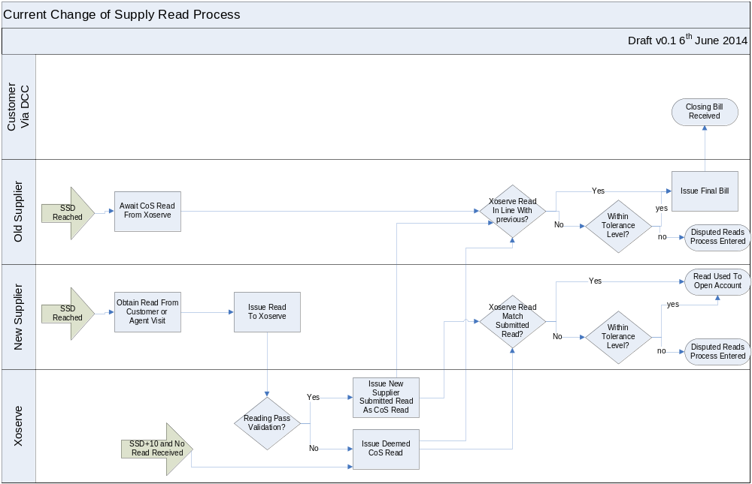

Appendix B - Future Process Map Option 1
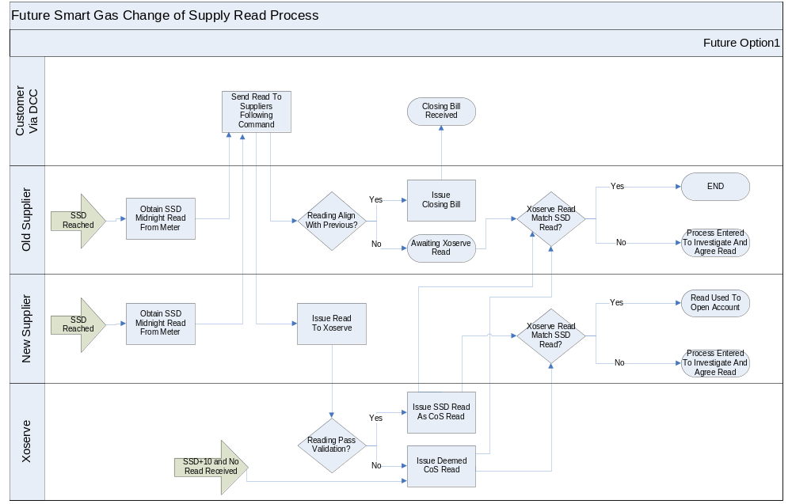

Appendix C - Future Process Map Option 2
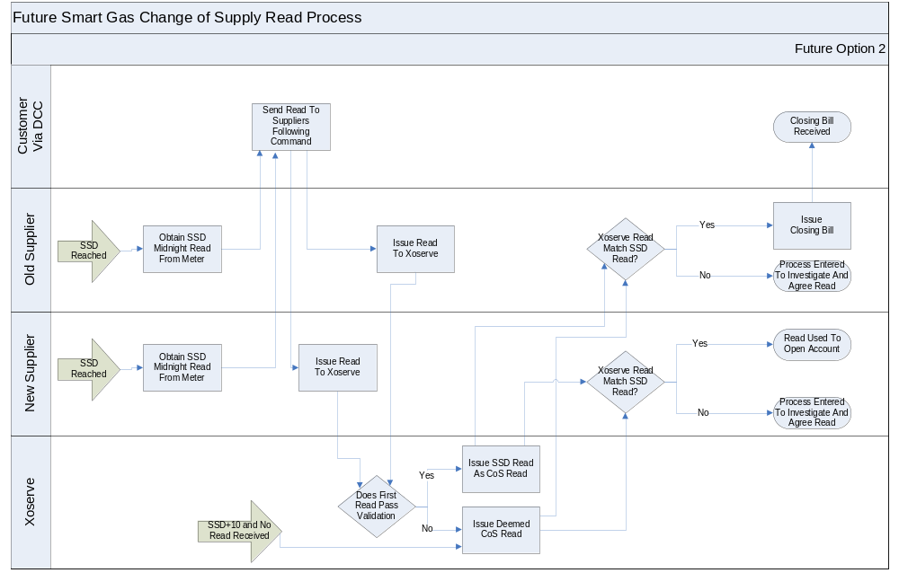

As with the current process, if neither submits it by SSD+15, Xoserve would generate an estimate. Since the old supplier is normally the first supplier to bill, it would be expected that the old supplier would generally be the party to send the CoS read into Xoserve so they can get it validated quickly for rapid billing. In this event, on receipt of Xoserve’s read the new supplier would simply check it against their own meter read, rather than submitting a separate CoS read to Xoserve.
Including resolution of the causes of issues in central systems as necessary
The process for transfer reads is set out in Section M3.8 of the UNC and the process for transfers from an SPA perspective are included in Section G. There are no formal SLAs currently in the code for responding to the Transfer Read File. However, there is an inference in Section M whereby shippers have until D+10 to submit the transfer read before Xoserve produces an estimate at D+12. Within Section G there are also numerous references to Xoserve responding within 2 business days regarding transfer file flows such as nominations, confirmations etc. Nevertheless the 2 day SLA is widely recognised by the industry as a standard for all Xoserve electronic process responses. Xoserve have advised that where UNC does not state any specific timings, they operate to the 2 business day standard.
Xoserve also noted that up to 2 days are necessary to account for pinch points on the system, e.g. systems outages or planned impactful events such as the annual AQ Review.

