iGT RGMA

GUIDANCE DOCUMENT – VERSION 0.3 DRAFT

1st June 2015

This document acts as guidance for parties wishing to understand how iGTs (those listed herein) utilise RGMA to support iGT metering activities. This document is not a legal agreement and does not create obligations between any parties (iGT, Supplier, MAM or MAP).

PUBLIC

DRAFT
THIS DOCUMENT IS STILL IN DEVELOPMENT AND SHOULD NOT BE RELIED UPON BY ANY PARTY TO DEVELOP SYSTEMS OR PROCESSES.

Table of Contents
1. Introduction 3
1.1 Included iGTs 3
1.2 Background 3
1.3 Purpose of this Guidance Document 3
1.4 Note on Contractual Position 4
2. File Structure and Transmission 5
2.1 Headers and Trailers 5
2.2 File Naming Conventions 5
2.3 File Extensions 5
2.4 Method of File Transmission 5
3. iGT RGMA Summary 6
4. Meter Works 10
4.1 Introduction 10
4.2 Process Flow 10
4.3 File Formats 11
4.4 Exceptions 12
4.5 Additional Information 12
Quoting for Meter Works 12
5. Change of Shipper 13
5.1 Introduction 13
5.2 Process Flow 13
5.3 File Formats 14
6. Miscellaneous Updates 15
6.1 Introduction 15
6.2 Process Flow 15
6.3 File Formats 15
7. Response Files 17
7.1 Supplier Response Files 17
7.2 File Formats 17
8. Query Management and Invoicing 18

Introduction

1.1 Included iGTs

This document applies to the following iGTs (or those under the following parent companies):

- Brookfield Utilities Ltd (MAM Shortcode: ???)
- ESP Utilities Group Ltd (MAM Shortcode: EPS)
- Indigo Pipelines Ltd (MAM Shortcode: ???)
- Energetics Networked Energy Ltd (MAM Shortcode: ???)
- Fulcrum Pipelines Ltd (MAM Shortcode: N/A)

Any reference made to iGTs in this document is a reference to the iGTs listed above only. Those MDD Shortcodes quoted are to clarify the parties that agree to adhere to this document (as the minimum implementation of RGMA flows). Readers should be aware that potential changes to MDD Shortcodes may not be reflected in the most recent published Guidance Document.

1.2 Background

RGMA defines the standards for electronic file formats to be used between Suppliers, MAMs and other industry parties, for metering competition related interfaces. IGTs provide metering services to gas shippers through its contract under the iGT Uniform Network Code (“iGT UNC”). The iGT UNC contains the provisions that govern both the commercial and data transfer elements of this service.

In June 2013, Ofgem approved SPAA Change Proposal CP 12/227, which mandated the use of Schedule 22 (SPAA Metering Schedule) and RGMA by Small Transporters. The implementation of CP 12/227 is aligned with Single Service Provision go live.

Where a supplier and an iGT MAM have contractual arrangements in place for metering services which sit outside of the iGT UNC, both parties will utilise RGMA data flows, in accordance with Schedule 22 of SPAA (unless agreed otherwise in contract).

Where the metering service is delivered based on the provisions in the iGT UNC (under Part D), iGTs will continue to provide the service on the basis of its contract with the shipper. In addition to the processes in place with gas shipper customers, the relevant iGTs have agreed to send/receive certain RGMA data flows to/from gas suppliers, to support suppliers’ business processes.

1.3 Purpose of this Guidance Document

Engagement with suppliers during the development of this document demonstrated that there were considerable variances in supplier requirements. Each of the suppliers who fed into the iGT review provided iGTs with a unique view of the extent to which each wished to use RGMA flows with iGT MAMs. This document details the agreed minimum RGMA flows that iGTs (those listed in section 1.1 of this document) will send/receive in the delivery of metering services to gas shippers/suppliers. Any additional RGMA data services provided to suppliers will be subject to bilateral agreement with suppliers.

The guidance herein is designed to supplement the RGMA Baseline document, often referring to sections of the Baseline. The intent of this document is to provide suppliers with sufficient information to allow each to design and build its systems. This document does not form part of any code and contract, and does not include references to transactions between iGTs and consumers/MAMs/MAPs.

1.4 Note on Contractual Position

Currently, iGTs contract with shippers for the provision of metering services. Whereas RGMA was implemented subsequent to the development of commercial metering arrangements, for example in the case of NGM, iGTs have an obligation to send/receive RGMA flows prior to the agreement of contractual terms with suppliers.

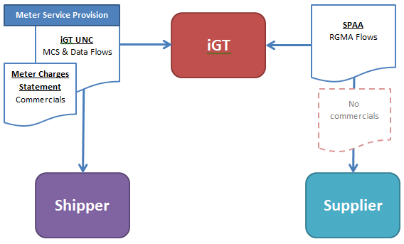
1: diagram, showing contractual relationship with both parties
Where an RGMA flow, for example asset works (ORJOB) or appointment (ONAGE) is sent from the supplier to the iGT, the flow will only have the required effect where the iGT MAM and supplier have the appropriate agreement in place.

Requests (i.e. where an ORJOB would otherwise be sent by a supplier under a supplier-MAM contract) made under the iGT UNC metering contract with the shipper will be carried out using the existing agreed processes, for those services that both parties have agreed to be provided.

File Structure and Transmission

2.1 Headers and Trailers

Headers and trailers used will be consistent with the format as published in the RGMA Baseline document, as amended from time to time.

2.2 File Naming Conventions

File Naming Conventions used will be consistent with the format as published in the RGMA Baseline document, as amended from time to time.

2.3 File Extensions

File Naming Conventions used in the relevant RGMA flows will reflect the format of the RGMA Baseline, as amended from time to time. For clarity, the extensions of the minimum files to be sent between iGT MAMs and suppliers are below:

Incoming Files (from supplier to iGT) | Extension
Asset Work Notification Response | RNJ
Provide Asset Details Response | RNU
Outgoing Files (from iGT to supplier) | Extension
Asset Work Notification | ONJ
Provide Asset Details | ONU

2.4 Method of File Transmission

All IGTs are looking to use the same industry standard communication method for transmitting and receiving files, or an alternative method where it has been bilaterally agreed between the supplier and IGT

IGT RGMA Summary

The following is a high level view of the minimum RGMA flows used by iGTs (and sent to/from suppliers) in the provision of metering services to gas shippers. The table also shows where RGMA flows will not be sent (those struck through) – where this is the case, an explanation has been provided in the ‘Comments’ column as to why the use of the RGMA process is not possible or does not support the contractual arrangements in place.

Ref: | File Type | File Reference (RGMA Baseline 5.9) | Related Physical Process Flows | Comments
 | Request Job | 15.1 Request Job – ORJOB | 1B – Request Asset Installation *  2B – Request Asset Removal  3B – Request Asset Exchange | - IGT MAM takes instructions to carry out work via PSR process (notification sent upon installation, see 2 below) on new housing developments and infill schemes.  - No contract with supplier. Agreement reached with shipper outside of RGMA, using existing processes.  - An ORJOB request from a supplier represents a request from a party with which the iGT has no contract to undertake the requested work.
 | Notify Metering Job Details | 15.2 Notify Metering Job – ONJOB  (This is work completed only, or the status e.g. re-planned) | 1C/D – Pre-notification of Asset Installation*  2C/D – Pre-notification of Asset Removal  3C/D– Pre-notification of Asset Exchange  1J /K – Notification of Asset Installation  2J /K – Notification of Asset Removal  3J /K – Notification of Asset Exchange | - IGT will send ONJOB notifications to supplier for all installations, removals and exchanges carried out by the iGT MAM.  - Impractical (inefficient for customer) to send pre-notifications on new housing and infill schemes.  - Pre-notifications will continue to be sent to shipper where currently issued, in existing format.  - Existing aborted visit notification to shipper will be sent outside of RGMA, using existing processes (e.g. by email).
 | Request Metering Quotation | 15.3.1 Request Metering Quote – ORQUO  15.3.2 Notify Metering Quote – ONQUO | P6C – Request Metering Price  P6G – Notify Metering Price | - Prices provided to shipper outside of RGMA (e.g. Meter Charges Statement)  - Ad hoc quotations obtained by shipper through existing process.
 | Notify Agent Change | 15.4 Notify Change of Agent – ONAGE | 6N / 8A – Notification of De-Appointment  6P / 8C – Notify New MAM of their Appointment | - New housing and infill scheme iGT MAM appointment will continue via PSR process.  - IGTs cannot be de-appointed on their assets (due to iGT being liable as GAO), unless agreed in relevant contract. Process for such a de-appointment to be agreed bilaterally between iGT and shipper.  - IGTs will not accept MAM appointment on third party owned assets, unless agreed in relevant contract. Process for such an appointment to be agreed bilaterally between iGT and shipper.  - IGT MAM will send incoming supplier ONUPD meter details on a change of supplier (as row #7 below).
 | Request Metering Details | 15.5 Request Metering Details – ORDET – Request for  information. | 6R – Request for Transfer of Asset Information | - IGTs cannot be de-appointed on their assets, unless agreed in relevant contract.  - IGTs will not accept MAM appointment on third party owned assets, unless agreed in relevant contract.  - Given the above, no requirement for iGT MAM to send/receive meter details from any third party MAM, unless agreed in contract with shipper/supplier.
 | Notify Metering Details | 15.6 Notify Metering Details – ONDET. MAM to MAM Provision of latest information. | 6T /8D – Transfer of Metering details Update | - As per above ‘5. Request Metering Details’.
 | Notify Update Details | 15.7 Notify Update Metering Details – ONUPD  Misc Notify Address Update - OSUPD | 2L & 3L – Notify Asset Collection Details  6U / 8E / 8F – Notification of successful transfer | - IGT MAM will send incoming supplier ONUPD meter details on a change of supplier, within 2 Business Days of D-2.  - IGT MAM will send supplier ONUPD where details have been updated (e.g. as a result of a shipper query).  - OSUPD is not required, as iGT MAM will be notified of address update through the shipper/Xoserve. Supplier may wish to send, but an iGT response may not be sent.
 | Response | The following are response files: | See ’15.8 Response’
 |  | RRJOB – Request Job | 1BR – Request Asset Installation  2BR – Request Asset Removal  3BR – Request Asset Exchange | - Originating flow not sent/received by iGT.
 |  | RNJOB – Notify Metering Job Details | 1CR/DR – Pre-notification of Asset Installation  2CR/DR – Pre-notification of Asset Removal  3CR/DR – Pre-notification of Asset Exchange  1JR /KR – Notification of Asset Installation  2JR /KR – Notification of Asset Removal  3JR /KR – Notification of Asset Exchange | - RNJOB expected in response to ONJOB.
 |  | RRQUO- Request Metering Quote | 6PCR | - Originating flow not sent/received by iGT.
 |  | RNQUO – Notify Metering Quote | 6PGR | - Originating flow not sent/received by iGT.
 |  | RNAGE – Notify Agent Change | 6PR (6Q) & 8CR – Appointment Request  6NR (6S) & 7AR – Confirmation of De-Appointment | - Originating flow not sent/received by iGT.
 |  | RRDET – Request Metering Details | 6RR – Request Metering Details | - Originating flow not sent/received by iGT.
 |  | RNDET – Notify Metering Details | 6TR & 8DR – Notify Metering Details | - Originating flow not sent/received by iGT.
 |  | RNUPD – Notify Update Details | 2LR & 3LR – Notify Asset Collection Details  6UR, 8ER & 8FR – Notify Update Changes (confirm successful transfer of information following CoS) | - RNUPD expected in response to ONUPD.

Meter Works

4.1 Introduction

RGMA ONJOB flows will be sent to suppliers following the completion of site works (carried out at the request of the shipper) for the following processes:

- New meter installation on:
  - New connections on new housing developments or infill schemes;
  - ‘one off’ new connections (where no meter had been previously);
  - Connections where a meter has been removed sometime previously;
- Asset removal;
- Asset Exchange (incl. reposition).

RGMA flows, together with their corresponding response files, will not be sent to suppliers in the following circumstances:

- Pre-notification of asset installation (ONJOB);
- Aborted or rescheduled asset works (ONJOB);
- Asset works request (ORJOB).

4.2 Process Flow

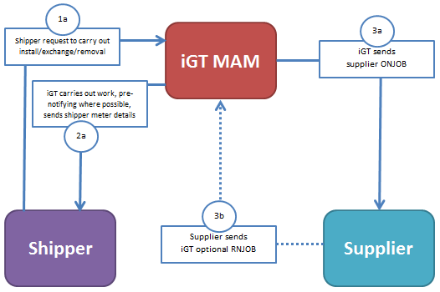
2: DIAGRAM SHOWING FLOW OF INFORMATION ON ASSET WORKS
Note: References (e.g. “1a”) on all diagrams are not references to any other document.

4.3 File Formats

Notify Metering Job – ONJOB

For schematic and file transaction format, refer to RGMA Baseline.

Mandatory Data Items

Please note that the file structures within this document will adhere to those published in the RGMA baseline document. The data items identified below represent the minimum data fields which will be populated within each file.

Meter Installation

1 | Transaction | A0177 – Record Identifier  A0055 – Transaction Reference  A0056 – Transaction Comment*  A0144 – Transaction Type Code e.g. INSTL  A0068 – Registration Body  A0069 – Registration Reference  A0166 – Date of Notice
1.1 | Meter Point | A0177 – Record Identifier  A0072 – Meter Point Reference
1.1.1 | Asset | A0177 – Record Identifier  A0144 – Transaction Type Code e.g. INSTL  A0024 – Asset Class Code e.g. METER  A0085 – Meter Mechanism e.g. PP  A0022 – Serial Number  A0059 – Location Code
1.1.1.2 | Meter | A0177 – Record Identifier  A0126 – Role Code (e.g. ‘S’ Supplier Gas Act Owner)  A0149 – OAMI Inspection Date
1.1.1.4 | Register Detail | A0177 – Record Identifier  A0124 – Register Type Code e.g. METER
1.1.1.4.1 | Reading | A0177 – Record Identifier  A0031 – Read Date  A0033 – Reading
*Will be mandatory for all new installations and will contain full concatenated address data, including plot number, where known.

Meter Removal

1 | Transaction | A0177 – Record Identifier  A0055 – Transaction Reference  A0056 – Transaction Comment*  A0055 – Transaction Reference  A0144 – Transaction Type Code e.g. REMVE  A0068 – Registration Body  A0069 – Registration Reference  A0166 – Date of Notice
1.1 | Meter Point | A0177 – Record Identifier  A0072 – Meter Point Reference
1.1.1 | Asset | A0177 – Record Identifier  A0144 – Transaction type Code e.g. REMVE  A0024 – Asset Class Code e.g. METER  A0022 – Serial Number
1.1.1.4 | Register Detail | A0177 – Record Identifier  A0124 – Register Type Code e.g. METER
1.1.1..1 | Reading | A0177 – Record Identifier  A0031 – Read Date  A0033 – Reading
*Will be mandatory for all new installations and will contain full concatenated address data, including plot number, where known.

Other Meter Works (e.g. reposition, found assets, other visits)

1 | Transaction | A0177 – Record Identifier  A0055 – Transaction Reference  A0056 – Transaction Comment*  A0055 – Transaction Reference  A0144 – Transaction Type Code e.g. REPSN  A0068 – Registration Body  A0069 – Registration Reference  A0166 – Date of Notice
1.1 | Meter Point | A0177 – Record Identifier  A0072 – Meter Point Reference
1.1.1 | Asset | A0177 – Record Identifier  A0144 – Transaction type Code e.g. RESPN  A0024 – Asset Class Code e.g. METER  A0022 – Serial Number  A0059 – Location Code (to new location)  A0178 – Data Update Code e.g. UPDTE
1.1.1.4 | Register Detail | A0177 – Record Identifier  A0124 – Register Type Code e.g. METER
1.1.1.4.1 | Reading | A0177 – Record Identifier  A0031 – Read Date  A0033 – Reading
*Will be mandatory for all new installations and will contain full concatenated address data, including plot number, where known.

4.4 Exceptions

Where a Works Request has been agreed with the shipper and has generated one or more exceptions, all exceptions must be resolved (between the iGT and shipper) before the submission of the ONJOB file. Shippers will be contacted by the iGT in order to resolve the exception(s).

4.5 Additional Information

Quoting for Meter Works

Where a meter works job does not have an associated agreed price, the shipper (or supplier, where a contract exists) may request a quote from the iGT MAM. To do this, the shipper (or supplier) approaches the MAM through the method agreed between the parties.

Change of Shipper

5.1 Introduction

Notify Update Details flow will be sent to the incoming supplier on each change of shipper event, as soon as practically possible after the change of shipper becomes unconditional. The relevant ONUPD will contain all the data the iGT MAM holds in relation to a particular meter.

The following RGMA flows, together with their corresponding response files, should not be sent by suppliers and will not be recognised by iGTs where the metering service is provided to the shipper:

- Request Metering Quotation (ORQUO);
- Appointment of Agent (ONAGE);
- De-appointment of Agent (ONAGE).

5.2 Process Flow

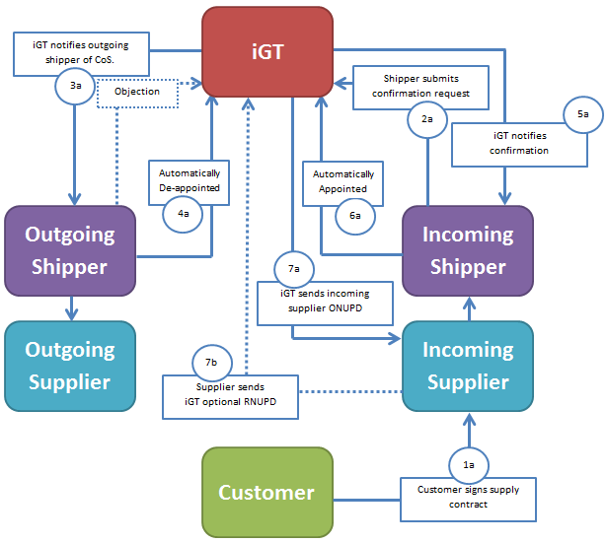
3: DIAGRAM SHOWING FLOW OF INFORMATION ON CHANGE OF SHIPPER

5.3 File Formats

Notify Update Details – ONUPD

For schematic and file transaction format, refer to RGMA Baseline.

Mandatory Data Items

Please note that the file structures within this document will adhere to those published in the RGMA baseline document. The data items identified below represent the minimum data fields which will be populated within each file.

1 | Transaction | A0177 – Record Identifier  A0055 – Transaction Reference  A0056 – Transaction Comment*  A0055 – Transaction Reference  A0144 – Transaction Type Code e.g. TRANS
1.2 | Meter Point | A0177 – Record Identifier  A0072 – Meter Point Reference
1.2.2 | Asset | A0177 – Record Identifier  A0144 – Transaction Type Code  A0024 – Asset Class Code e.g. METER  A0022 – Serial Number  A0059 – Location Code  A0037 – Asset Status  A0028 – Installation Date
1.2.2.2 | Meter | A0177 – Record Identifier  A0149 – OAMI Inspection Date  A0126 – Role Code (for Gas Act Owner)
1.2.2.4 | Register Detail | A0124 – Register Type Code e.g. METER  A0121 – Number of Dials  A0123 – Units of Measure  A0120 – Multiplication Factor
*Will be mandatory for all new installations and will contain full concatenated address data, including plot number, where known.

Miscellaneous Updates

6.1 Introduction

Notify Update Details (ONUPD) flows will be sent to suppliers where the iGT MAM has become aware that meter details have changed or new data has become available. For example, this may be due to a resolved shipper query.

6.2 Process Flow

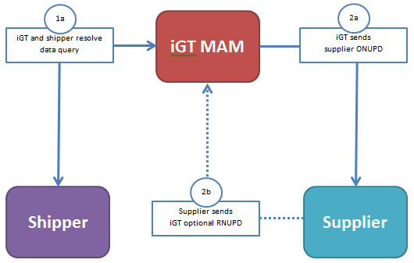
4: DIAGRAM SHOWING FLOW OF INFORMATION ON A MISCELLANEOUS UPDATE

6.3 File Formats

Notify Update Details – ONUPD

For schematic and file transaction format, refer to RGMA Baseline.

Mandatory Data Items

Please note that the file structures within this document will adhere to those published in the RGMA baseline document. The data items identified below represent the minimum data fields which will be populated within each file.

1 | Transaction | A0177 – Record Identifier  A0055 – Transaction Reference  A0056 – Transaction Comment*  A0055 – Transaction Reference  A0144 – Transaction Type Code e.g. UPDTE
1.2 | Meter Point | A0177 – Record Identifier  A0072 – Meter Point Reference
1.2.2 | Asset | A0177 – Record Identifier  A0178 – Data Update Code e.g. UPDTE**  A0144 – Transaction Type Code  A0024 – Asset Class Code e.g. METER  A0022 – Serial Number  A0059 – Location Code  A0037 – Asset Status  A0028 – Installation Date
1.2.2.2 | Meter | A0177 – Record Identifier  A0149 – OAMI Inspection Date  A0126 – Role Code (for Gas Act Owner)
1.2.2.4 | Register Detail | A0124 – Register Type Code e.g. METER  A0121 – Number of Dials  A0123 – Units of Measure  A0120 – Multiplication Factor
*Will be mandatory for all new installations and will contain full concatenated address data, including plot number, where known.
** If A0178 is blank then all the information contained in the record/data set is new data or for reference purposes (i.e. no change to data within the record).

Response Files

7.1 Supplier Response Files

Suppliers may optionally produce the following response files to the notification files detailed in this document:

- RNJOB
- RNUPD

Where a Supplier rejects a file due to errors in the file format, the iGT will manually handle any rejections contained within the response file and will attempt to resolve on a reasonable endeavours basis.

7.2 File Formats

RNJOB and RNUPD files to be sent in accordance with RGMA Baseline document, as amended from time to time.

Query Management and Invoicing

IGTs and shippers will use existing iGT UNC processes to:

- Resolve any queries relating to data or service issues;
- Invoice shippers for metering services rendered.

Queries will be sent in a format and by methods currently used or otherwise agreed in future. SLAs for responding to queries should be commercially agreed between shippers (or suppliers) and iGTs.

Invoices will be issued on the basis specified in the contract with the iGT MAM/MAP. Invoice backing data will continue to be sent as per the contract under the iGT UNC, unless an alternative process is bilaterally agreed.

